**Group Project Brief**

Our brief is to use the theme “fear of darkness” and to create a game that induces psychological flow.

The theme “fear of darkness” will be the central point of the game and all design decisions should centre around this including mechanics, dynamics and aesthetics. However the most challenging element will be to accomplish psychological flow. The game will focus on trying to achieve Flow by focusing on the factors; Challenge VS Skill, Anxiety VS Boredom, Difficulty or Difficulty Balance. In an attempt to balance these elements and keep the player within the Flow Channel, the puzzles should follow a pattern such as outlined below.

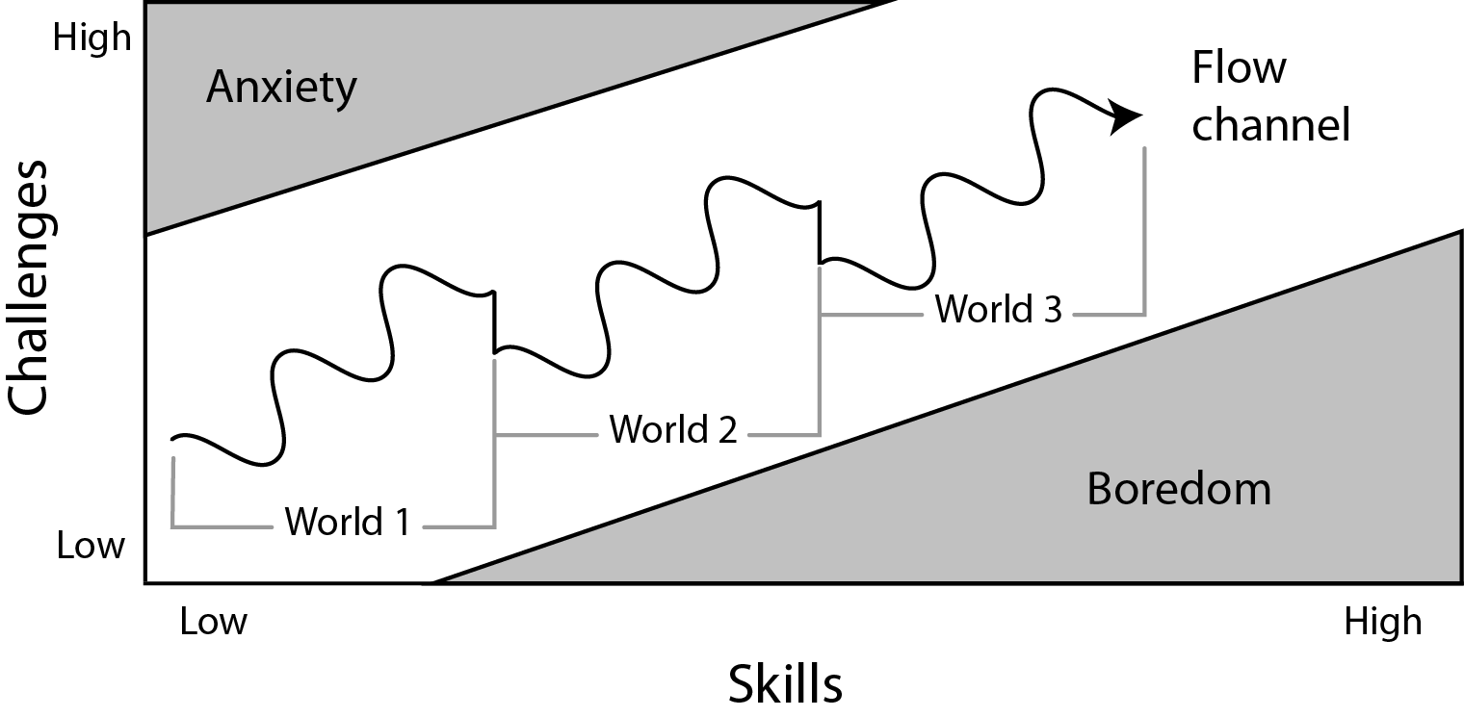

In the above diagram the player is increasing skill and challenge in a wave pattern, with dips in difficulty at the start of each new puzzle, section, world, mechanic etc. The intention of creating game play following this diagram is that there is variation in the gameplay between the difficulty, not just between sections but within each section. [Sala, T: 2013]

**Bibliography**

Sala, T (2013) *Game Design Theory Applied: The Flow Channel* [Online] Accessed On (26/07/17) Available At: <http://www.gamasutra.com/blogs/ToniSala/20131208/206535/Game_Design_Theory_Applied_The_Flow_Channel.php>